Lunar Lander
Author: John Osborne
Class: 1F1

TOC

Analysis

Project Identification
For my extended coursework project I will aim to create a version of the classic arcade game / simulation ‘Lunar Lander’. This model of space flight will be pitched to the stakeholders as a tool to model the landing of their newly developed spacecraft on their first expeditions to the Moon and later Mars.
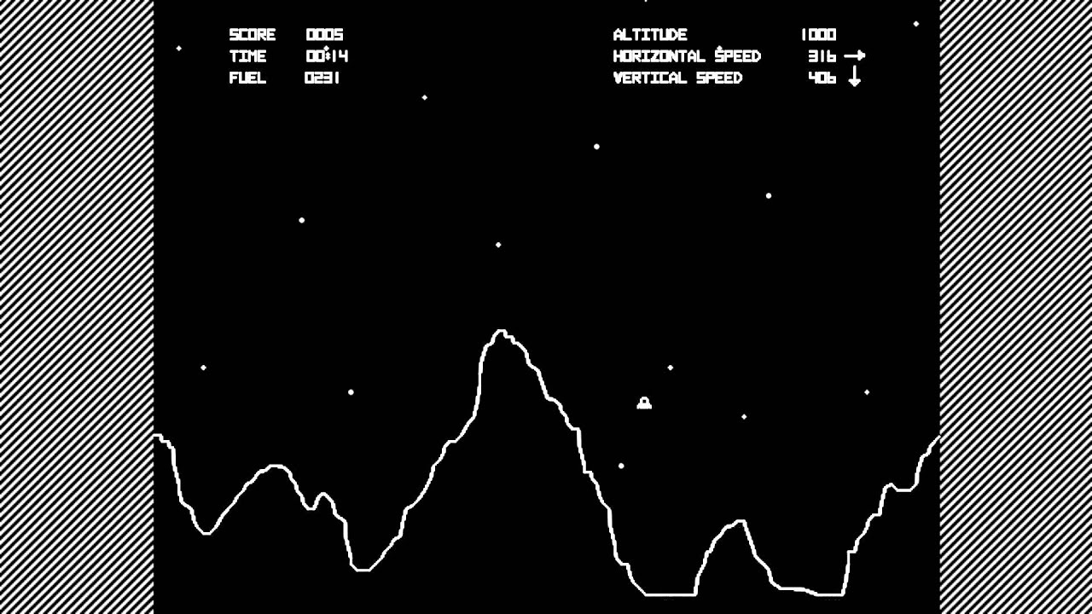
‘Lunar Lander’ is a whole is a sub-genre of games that simulates gravity and landing a spaceship – often on a fictional moon. The original text-based game was released in 1969 on the PDP-8 minicomputer. Many version and ports have been developed, including instructional BASIC programs realeased in the 1970s-1980s and versions released on arcade machines with wire-frame 2D graphics. It became extremely popular due to these arcade machine release.
The main objective is to land a ship at a low enough velocity on a flat area so as to not destroy the ship. This gameplay is made more difficult by sensitive controls and fuel limits, like in a real world scenario. The score is then determined, by time spent landing and fuel used, then added to a highscore table. These scores can be used to determine the best method of flying the ship. Lander is most often played with a single user (controlling a single ship) and if a user is to land successfully the ship must land with a bearing close to 000° and as small a velocity as possible (often limited by fuel reserves).
Many players take the approach of lateral flight and then free fall until a certain distance above ground (in order to save fuel) then run a ‘suicide burn’ to reduce the velocity to zero at the instant the ship lands. I’d like to try and test this method for the stakeholders along with attempting other similar methods .
On the Atari version from 1979 (with which I shall base my version) the game has a splash screen allowing the user to enter credits for fuel and hit start to launch the ship. The user interface is comprised of; ‘score’, ‘time’, ‘fuel’, ‘altitude’, ‘horizontal speed’ and ‘vertical speed’ text elements at the top of the screen.
These are all very important pieces of information to know if you want to land your ship successfully. For example, if you are approaching one of the landing zones you will need to know by how much to decrease your vertical speed by firing thrusters. In addition, when you fire your thrusters you must stay aware of how much fuel you have used and how much you have remaining, shown by the ‘fuel’ UI element.
The ‘moon’s surface’ is a simple wireframe. Along it’s surface there are flat areas used as landing pads, the only safe places to land. These are the areas to aim for as you descend. Another key game mechanic is introduced by these landing pads as the larger the area the easier it is to land and therefore the smaller the score multiplier. These range from 2x up to 5x, where 5xs are the smallest landing area. In the model for the stakeholders our multipliers will indicate the most adavantgeous areas for research.
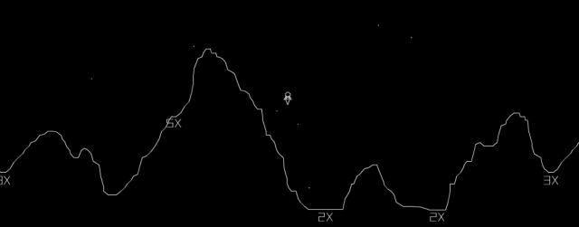
When the new version of Lander has been created it will differ in a few areas.

Computational Methods

Why create a ‘Lunar Lander’ type game?
Now that comercial space flight will soon be a reality, the reliability and reproducability of each journey is paramount. But, what is the best way to land a space craft full of people on the moon? Using models and simulation we can start to answer this question.
In our program we must be able to; simulate newtonian physics (including gravity), represent a ship with rocket engines that burn fuel and represent the surface of a body with a given topology.
Computationally solving this problem will be much more suitable than making a real life model and testing landing methods for real. This is because there is, in practice, zero risk to life or expensive machinery when using a computer. Also, the time frames over which tests can be done are much smaller than in real life. For example, resetting the simulation can be done instantaneously and the simulation does not have to be run in real time.
Abstraction is the process of removing erroneous and irrelevant data. This is particularly useful in computer science as it helps us to only consider necessary information and solve problems succinctly. In our model many abstractions will be made so only the key physical elements and pieces of data will be considered. One such abstraction is the simple wireframe graphical representation of the ship and the Moon’s surface. This simplifies the detail of the surface allowing the simulation to run faster (requires less processing) and if a height map of the surface is saved to disk then the file sizes can be kept to a minimum. In simulating the gravity of the moon acting on the lander, I will use a simple Newtonian model as opposed to a relativistic model – at this scale the effects of relativity are irrelevant.
When thinking computationally it can help to decompose issues, look for patterns and smaller problems that can be solved seperately to contribute to the solution of the encomapssing more complex problem. Once we have abstracted the appropriate information (like previously when decieding to use a newtonian model) we will break down and compartmentalise a problem – e.g. our physics model. Part of the physics system must handle gravitational attraction between objects and in our case thats the ship and the moon. Another decomposition upon the physics system would control the engines on the ship creating a resultant force and therefore it’s acceleration.
When developing this program I will need to decide on:
- how to design of the UI?
- how to handle user input (most likely using arrow keys)?
- the graphical style?
- any libraries used for physics, audio or rendering?
- how best to suit the design for the stakeholders and their tests?
- will the different sections of the program be handled concurrently? Will the rendering be done at the same time as the calculations or will this introduce errors with collision and movement?
- how to test (white box, black box, etc..)

Stakeholders
I have aquired stakeholders for this project in the form of a SpaceX-NASA partnership and George.
SpaceX and NASA have been striving towards commercial and reliable space flight in the near future and require tools for testing new ships and flight plans. For their Lunar missions a landing sequence must be developed and throughly tested before any real flights take place. Finding suitable testing methods that accurately recreate the conditions of a spaceship landing on the moon is hard to do when not on the moon in real life. Therefore solving this computational solution is much more applicable and can be done with much less risk. No money has to be spent on sending a vessel in to space and if the mission fails it can be very quickly reset at zero cost. They will test the code on its accuracy and useability over the course of its development relaying their opinions and knowledge on spaceflight in order to improve the product. Then at the end of the development cycle they will use the product in their own research. Modelling specific
In George’s case, he has been looking for a space exploration game to fill his time and also has a keen interest in old arcade machines and games so a game modelled on the

Initial Research

Notes
add online score table

